Step 1: Importing Libraries

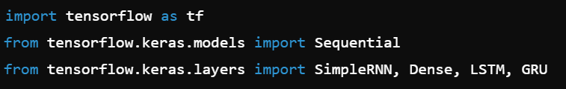

Explanation:
- ‘tensorflow’ is the core library for machine learning tasks.
- ‘Sequential’ is a linear stack of layers in Keras, a high-level API of TensorFlow.
- ‘SimpleRNN’, ‘LSTM’, and ‘GRU’ are different types of recurrent layers.
- ‘Dense’ is a standard densely-connected neural network layer.

Step 2: Defining the RNN Model

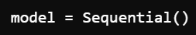

Explanation:
- ‘Sequential()’ initializes a linear stack of layers.

Step 3: Adding a Simple RNN Layer

Explanation:
- SimpleRNN(50): Adds a Simple RNN layer with 50 units.
- input_shape=(timesteps, input_dim): Specifies the shape of the input data, where timesteps is the number of time steps in each input sequence, and input_dim is the dimensionality of each input vector.
- return_sequences=True: Ensures that the output of the RNN layer is a sequence (required if another RNN layer follows).

Step 4: Adding an LSTM Layer

Explanation:
- LSTM(50): Adds an LSTM layer with 50 units.
- return_sequences=True: Ensures that the output of the LSTM layer is a sequence.

Step 5: Adding a GRU Layer

Explanation:
- GRU(50): Adds a GRU layer with 50 units.
- return_sequences=True: Ensures that the output of the GRU layer is a sequence.

Step 6: Adding a Dense Output Layer

Explanation:
- Dense(output_dim): Adds a fully connected layer with output_dim units.
- activation='softmax': Uses the softmax activation function, typically used for classification tasks.

Step 7: Compiling the Model

Explanation:
- optimizer='adam': Uses the Adam optimizer for training.
- loss='categorical_crossentropy': Specifies the loss function as categorical crossentropy, commonly used for classification problems.
- metrics=['accuracy']: Specifies accuracy as the metric to evaluate the model's performance.

Step 8: Model Summary

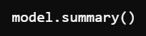

Explanation:
- model.summary(): Prints a summary of the model architecture, including the layers and the number of parameters.

Step 9: Training the Model

Explanation:
- X_train, y_train: Training data and corresponding labels.
- epochs=10: Number of epochs to train the model.
- batch_size=64: Number of samples per gradient update.
- validation_data=(X_val, y_val): Validation data and corresponding labels for evaluating the model during training.

Detailed Steps for Training the Model

Epoch Loop:
The training process runs for the specified number of epochs (in this case, 10).

Batch Processing:
During each epoch, the training data is split into batches (in this case, of size 64).
Each batch is fed into the model for forward and backward propagation.

Forward Pass:
For each batch, the input sequences are processed through the RNN layers (SimpleRNN, LSTM, GRU) and the Dense output layer.
The model computes the output probabilities using the softmax activation function.

Loss Calculation:
The categorical cross-entropy loss is calculated between the predicted probabilities and the true labels.

Backward Pass:
The gradients of the loss with respect to the model parameters are computed.
The model updates its parameters using the Adam optimizer.

Validation:
After each epoch, the model's performance is evaluated on the validation data.
The validation loss and accuracy are calculated to monitor the model's progress and detect overfitting.

Output:
The model prints training and validation loss/accuracy for each epoch.

